# Lab: Text Processing

Problems for exercise and homework for the ["JS Fundamentals" Course @ SoftUni.](https://softuni.bg/trainings/3449/programming-fundamentals-with-javascript-september-2021)   
Submit your solutions in the SoftUni judge system at: <https://judge.softuni.org/Contests/1705>

## Print Characters

Write a function that **receives a** **string** and **prints all the** **characters** on separate lines.

### Input / Output

|  |  |
| --- | --- |
| **Input** | **Output** |
| 'AWord' | A  W  o  r  d |
| 'Sentence' | S  e  n  t  a  n  c  e |

### Hints

Loop through the string and print each character.

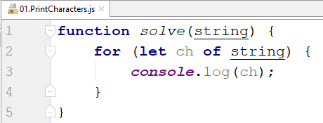

## Substring

Write a function that **receives a string** and **two numbers**. The numbers will be a **starting index** and **count** of elements to substring. Print the result.

### Input / Output

|  |  |
| --- | --- |
| **Input** | **Output** |
| 'ASentance', 1, 8 | Sentance |
| 'SkipWord', 4, 7 | Word |

### Hints

Create a new string that takes the needed amount of elements from the given string.

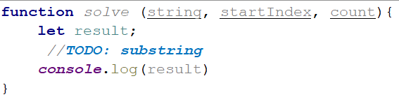

## Censored Words

Write a function that **receives a text as** a first parameter and a **single word** as a second. Find **all occurrences** of that word in the text and replace them with the corresponding count of '*'.

### Input / Output

|  |  |
| --- | --- |
| **Input** | **Output** |
| 'A small sentence with some words', 'small' | A ***** sentence with some words |
| 'Find the hided word', 'hided' | Find the ***** word |

### Hints

Save the new text in a new variable.

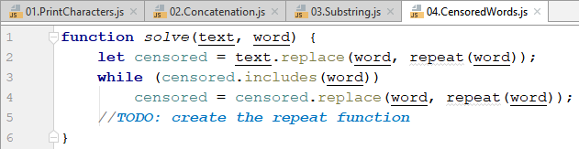

The repeat() function should take the length of the word and return that amount of stars '*'.

## Count String Occurrences

Write a function that **receives a text** and a **word that you need to search**. Print all the occurrences of that word in the text.

### Input / Output

|  |  |
| --- | --- |
| **Input** | **Output** |
| 'This is a word and it also is a sentence',  'is' | 2 |
| 'softuni is great place for learning new programming languages',  'softuni' | 1 |

### Hints

Split the sentence into words and create a **counter** that stores how many times the searched word occurs.

